**Manual Testing**

**Swagger page snapshot**

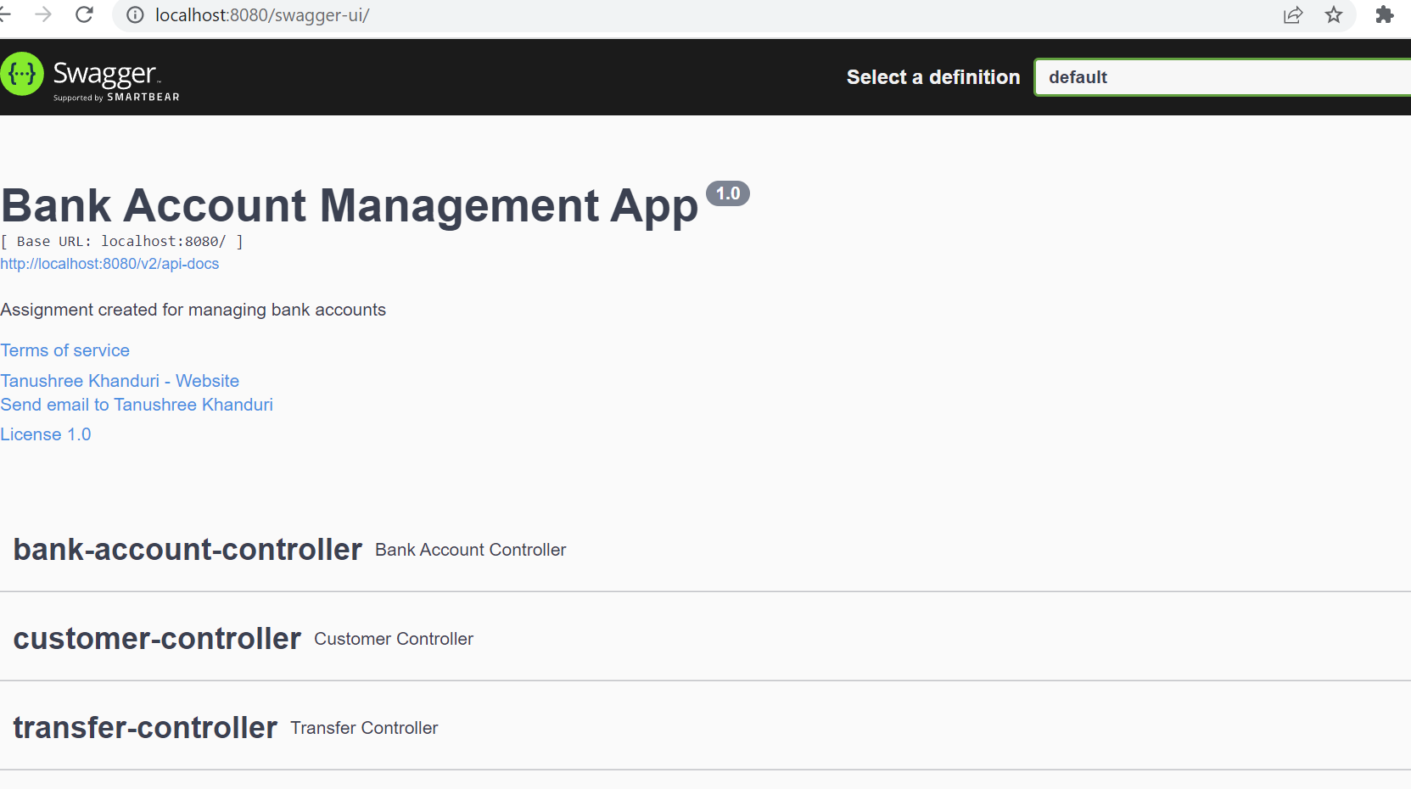

1. Endpoint to add new bank account

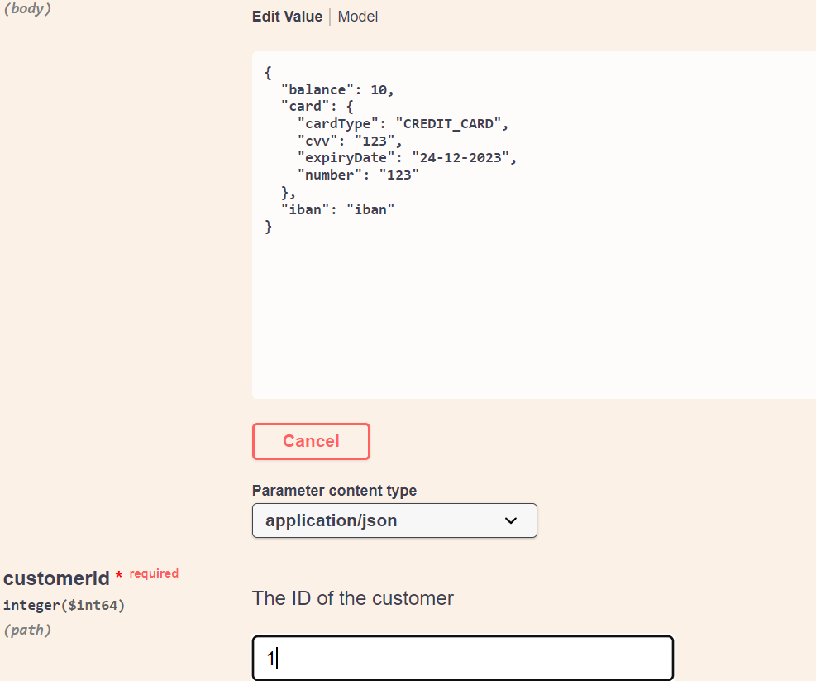

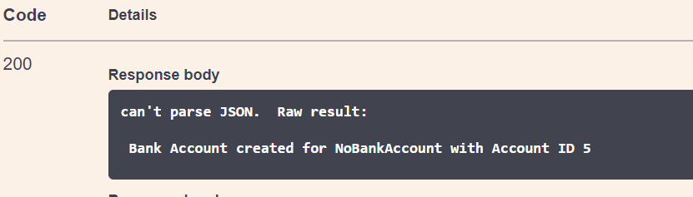

1. One rest endpoint to see current available balance in all accounts



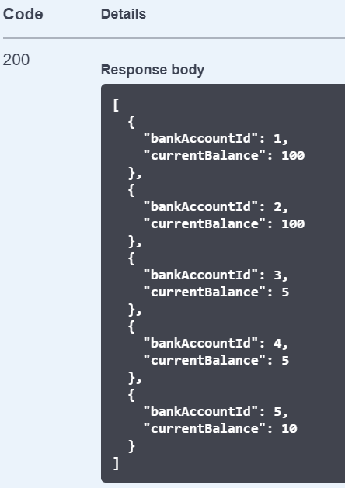

1. One rest endpoint to withdraw money

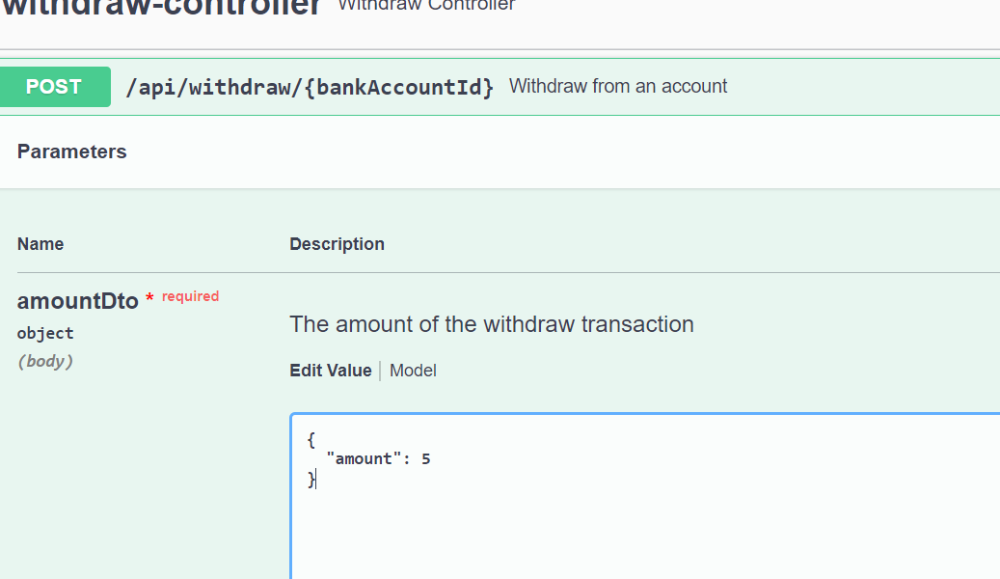

1. One rest endpoint to transfer money

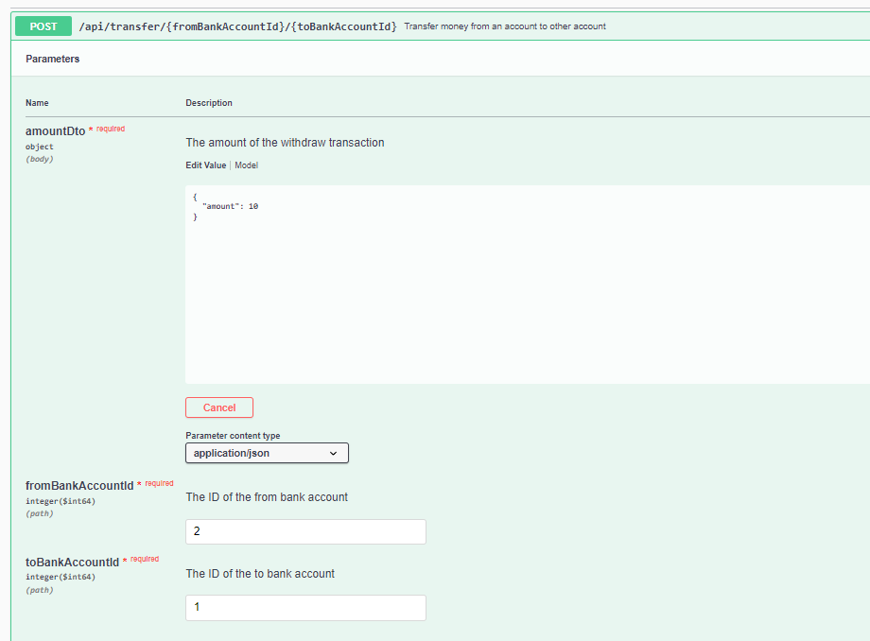

1. A negative balance is not possible

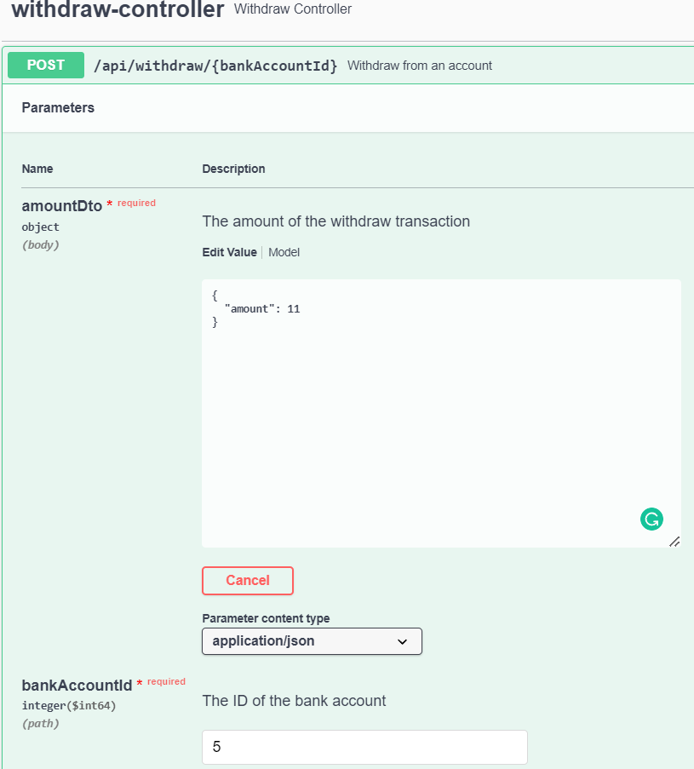

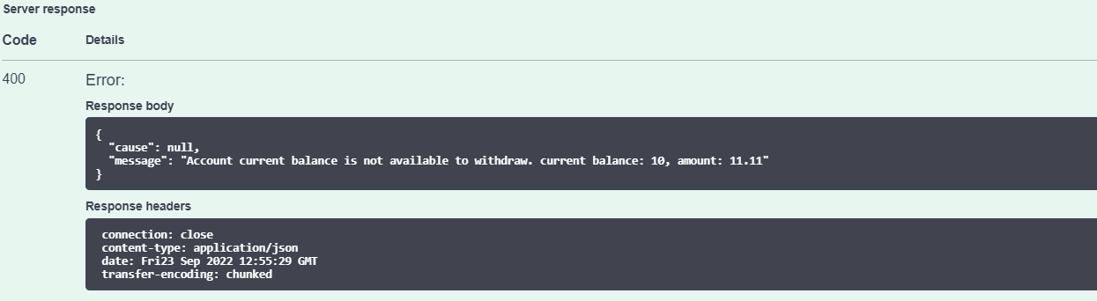

It should be able to audit transfers or withdrawals

